New Prospect Elementary School
School to Home Math Engagement for Families
Fifth Grade: 2023-2024
Math Unit | Links to Resources (Parents) | Links to Resources (Teachers)
Unit 1  Investigating Volume of Solid Figures | Cubes  (This student interactive, from Illuminations, helps students explore the volume of a box based on the amount of unit cubes that can fit inside of it. This does introduce students to surface area. Surface area is NOT a fifth-grade standard and therefore not an expectation for fifth grade students to know.)  Find the Volume – Math Game | Illustrative Mathematics Tasks
Unit 2  Building Conceptual Understanding of Place Value Using Measurement and Data Reasoning | Place Value Riddles  Place Value of Decimals-Study Jams  Interactive Place Value Chart  Metric Conversions  Customary Conversions | Illustrative Mathematics Tasks
Unit 3  Building Conceptual Understanding of Multiplication and Division with Whole Numbers | Make Sense of Multiplication and Division Word Problems | Illustrative Mathematics Tasks
Unit 4  Building Fraction Understanding | Comparing and Ordering Fractions  Ordering Fractions | Illustrative Mathematics Tasks
Unit 5  Making Sense of Fraction Multiplication and Division | Interactive Fractions  Dividing Whole Numbers by Unit Fractions | Relational Thinking Strategies  Number Sense Routines  Illustrative Mathematics Tasks  Open Middle
Unit 6  Extending Place Value and Working with Decimals to Solve Problems | Pixil Art  - Families can make designs and discuss the fraction and/or decimal of their design that is a certain color. | Illustrative Mathematics Tasks  Teachers can send home bags of colored tiles for students. Students can use the tiles to create designs using ten squares or 100 squares. Then, students can tell what fraction and/or decimal of their designs are a certain color.
Unit 7  Exploring Geometry and the Coordinate Plane | “Teacher Guidance” Documents were not linked in DOE learning plans to access resources – website says they are Coming Soon! Check back later to access. | Illustrative Mathematics Tasks
Unit 8  Culminating Capstone Unit |  | PBL to be completed during the last week(s) of School, or throughout the 2nd semester.

Additional Engagement Activities that are NOT Online:
Unit 1:
- Using cubes of the same size, challenge your family members to build rectangular prisms with a given volume (2 or 3-digit numbers). See how many different ways you can build a prism that has a specified volume. How does it relate to the given volume?
- As a family, explore how you can determine how many layers are in the box shown in the image. Determine what each layer might look like. (Use the image and chart below.)
- 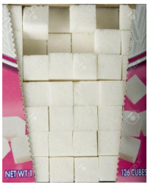
Number of Cubes | Number of Layers | Volume
 |  | 126 Cubes

Unit 2:
- Interactive Place Value Chart (see above) and Guiding Questions to Use:
  - What is 10ⁿ? (ⁿrepresents any number 1-9)
  - Is the magnitude of the number going to increase or decrease?
  - What is the product or quotient?
  - What pattern did you notice as the number increased or decreased by the power of ten?
- Measurement Conversion Conversations
  - Have students engage with their families by creating Family Outing Conversions. During a family outing encourage students and their families to create conversion experiences while engaging in simple activities. Activities such as:
    - While riding in the car, determine how many miles have been traveled using the car’s odometer. Challenge family members to convert the mileage to feet and/or yards.
    - While walking in the park, pay attention to the number of feet walked. Convert feet to miles.
Unit 3:
- Have students engage with their families by having each member share their favorite strategy for multiplying the following:
  - 23 x 34
  - 43 x 6
  - 123 x 23
- If a student’s family is not familiar with different strategies have the student teach their family member!
- Have students engage with their families by having each member share their favorite strategy for multiplying the following:
  - 276 x 34
  - 403 x 65
  - 126 x 83
- If a student’s family is not familiar with different strategies have the student teach their family member!
- Have student engage with their families with the activity. Holy Cow! My calculator does not have a 3 key that works! How can I use this broken calculator to do this problem? 23 x 45

- Partial Quotient Example
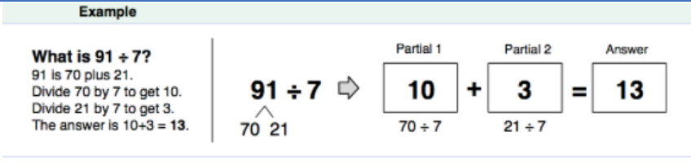
Students can work with families to practice some preselected partial quotient problems. Once they solve the problem can they practice creating a different equivalent expression.
- Sample Division Problem
  - Solve problems as a family. Family members can engage with each other to solve various division problems. Challenge each other to use various strategies. Ex problem: A new parking lot is going to have 3,648 parking spaces. If each row can have 24 parking spaces, how many rows will the parking lot need?
- Convince A Skeptic
  - One person will pose as the skeptic and one person will pose as the convincer. The convincer will write an expression to represent the scenario below and justify their expression convincingly enough for the skeptic to understand. The fifth grade is participating in the school-wide can drive. Each class has set a goal of collecting 225 cans. If there are 25 students in your class, how many cans will each student need to bring to achieve your class goal?
- Connection Strategies
  - The fifth grade is participating in the school-wide can drive. Each class has set a goal of collecting 225 cans. If there are 25 students in your class, how many cans will each student need to bring in order to achieve your class goal? Solve this problem using a strategy that makes sense to you. Ask a family to solve this problem using a strategy that make sense to them. Make connections between the strategies. Use the following sentence frames to support the mathematical dialogue:
    - “I noticed…so I looked for…”
    - “…connects to…because…”
- Plan a Celebration
  - Plan a celebration important to your family. Together, determine the total cost of the celebration. Determine a set of parameters before planning.
    - What is the budget?
    - How many people are invited?
    - Will the celebration require any rentals?
    - What’s on the menu?
    - Have fun as a family!
- Play the Mean Game
  - Need 2 or more players.
  - How to play:
    - If playing with only 2 players, each player picks 4 numbers between 1 and 10. Find the mean of all the numbers. The winner is the person who picked a number closest to the mean.
    - If playing with more than 2 players, each player picks 2 numbers between 1 and 10. Find the mean of all the numbers. The winner is the person who picked a number closest to the mean.
Unit 4:
- Using Number Sense to Explore Sums of Fractions:
  - Name the Fraction The purpose of this activity is to look at a fraction bar model as it relates to 1 whole and name the shaded amount on the second bar. Estimates do not need to include the same denominators. For example, one person may think that 1 2 is shaded and another person may think that 6 12 is shaded. Remember, as long as you can explain your thinking, it is accepted!
  - Look at the two fraction bars below. What fraction is shaded on the second fraction bar? Include an estimate that is too low, just right, and too high. Talk about why you made those estimates and how you know your “just right estimate” is correct. Are there other ways to write your estimates?
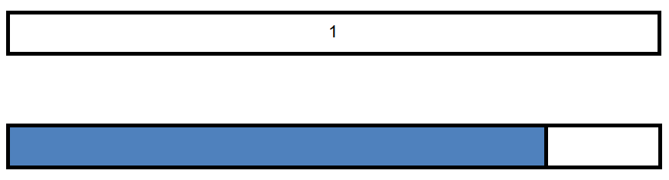
Too Low Estimate | Just Right Estimate | Too High Estimate

- Making 1!
  - Have students engage with their families by having family members find 3 fractions whose sum is 1. Using the digits 1 to 9, at most one time each, place a digit in each box to make a true statement.
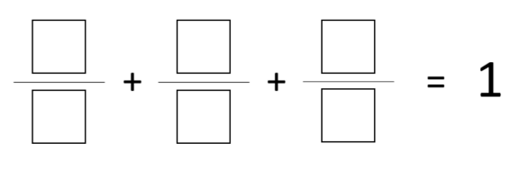
- Create 3
  - Using Equivalent Fractions and Representations: Create Three With a partner, each player chooses a fraction to place a counter on. Each player takes turns moving your counter to another faction along the lines only. Players add the new fraction to their total. The first player to make exactly three is the winner. Go over three and that player loses the game. Players should use an additional counter to keep a running total along the number line.
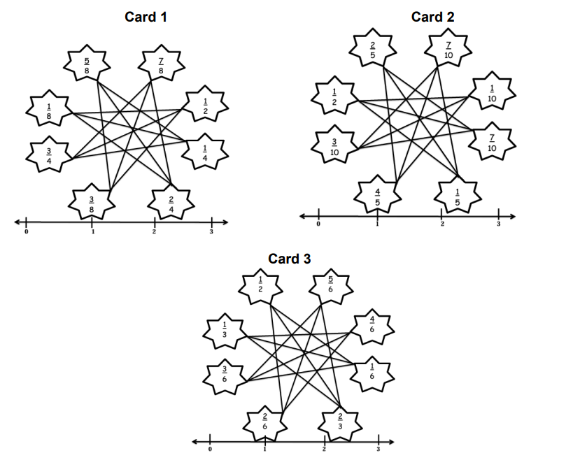
- Add and Subtract Fractions Opportunities
  - Such as, food is left over from the previous night’s dinner, like pizza. Allow families to determine how much was eaten. Who ate the most pizza, what fraction did they eat? Who ate the least. How much was eaten in total? What fraction of the pizza is left?
Unit 5:
- Division Game!
  - Families could use playing cards to fill in the blanks and represent the situations.
    - ____cookies for ____ children
- Try This!
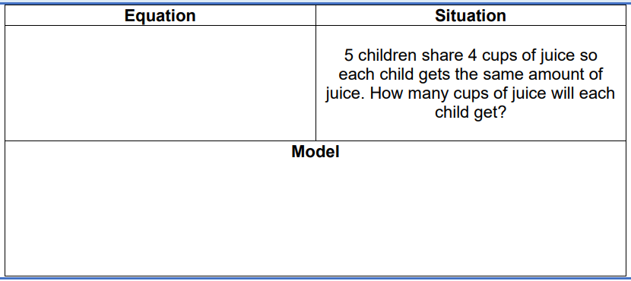
- Scale Drawings
  - In this activity, you can use the drawing that is given, or you can create your own drawing. You will recreate the same drawing that is two times the size and you will recreate the same drawing that is 1 2 the size. Grid paper is available to print.
- Multiplication Reasoning
  - Write a number in each box to make the statement true. Explain or show your reasoning.
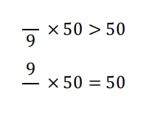
- Largest and Smallest Products
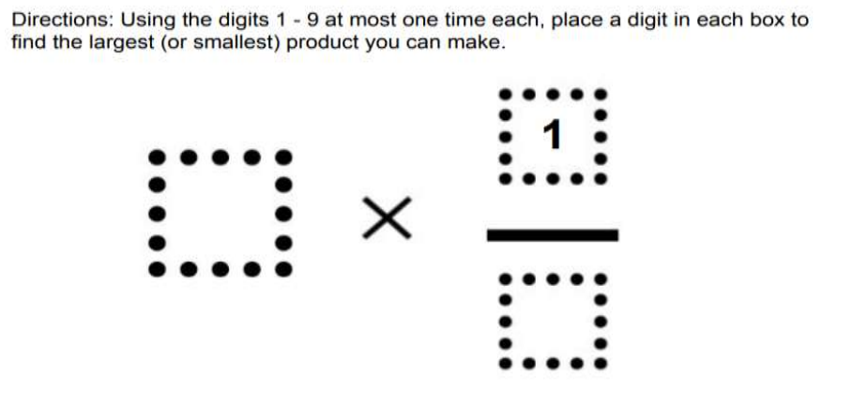
- Multiplying Mixed Numbers by Whole Numbers
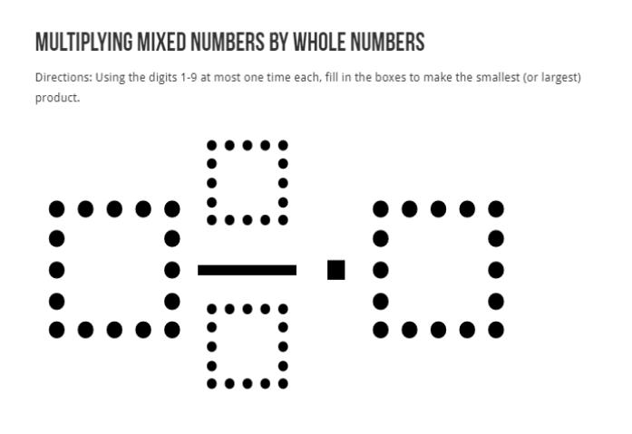
- Fraction Representation
  - Using the image below, engage your student in a conversation about the number of chocolates represented by each flavor. Students should write expressions and equivalent fractions to represent each flavor.
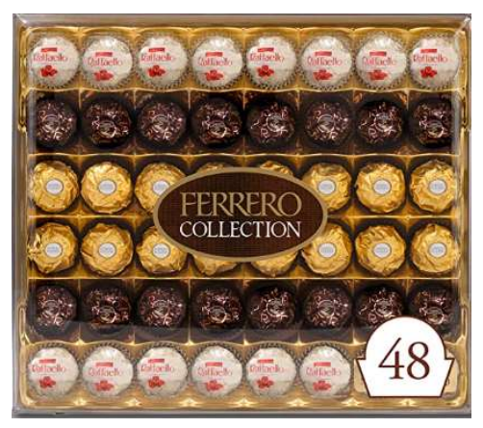
- Fractions of a Set
  - Using forks, plates, and spoons draw an image to represent your dinner table. Describe how you see fractions of a set in your image.
- For each statement, show a model to find the total amount in a whole. Then write an expression to represent the situation.
  - $36 is two-eights of Landon’s money.
  - $36 is six-fifths of Mikayla’s money
- Relational Thinking Strategies
  - What would happen if you doubled one factor? Doubled both factors? How would the visual representation change? How would the product change? Could you half one product? How would the visual representation change? How would the product change?
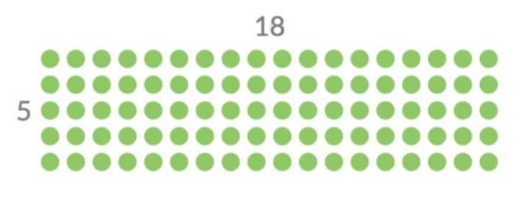
- Quotients
  - Using the digits 1 through 9, at most one time each, place a digit in each box to create two true equations: one where the quotient is greater than 40 and one where it’s less than 40. You may reuse the same digits for each of the equations.
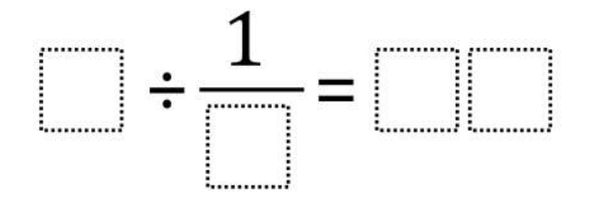

Unit 6:
- Example 1:
Look at the two images. What do you notice?
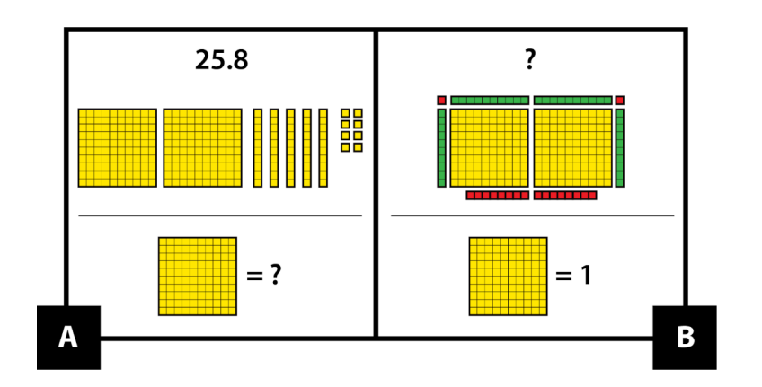
- How are pictures A and B the same, and how are they different?
  - A and B are the same because …
  - A and B are different because …
- Use base ten pieces to make a third picture that represents a number. Explain how your picture is the same as pictures A and B, and how it is different.
- Example 2:
Look at these race signs showing results of the same race. What do you notice?
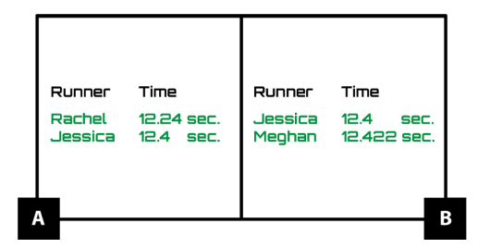
- How are pictures A and B mathematically the same, and how are they different?
  - A and B are the same because …
  - A and B are different because …
  - Make a third picture that compares decimals. Explain how your picture is the same as pictures A and B, and how it is different.
- Number Line Practice with Decimals
  - Write five decimals that you will be able to place on the number line below.
______________ ______________ ______________ _____________ _____________
  - Next, place the decimal numbers on the number line below. Add benchmark numbers as needed to the number line.
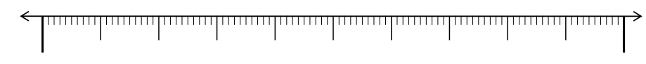

- High Roller Place Value-
  - Play with one person or play with many people. Each person needs a High Roller Place Value Mat. Each family will need one die. Click HERE for virtual dice.
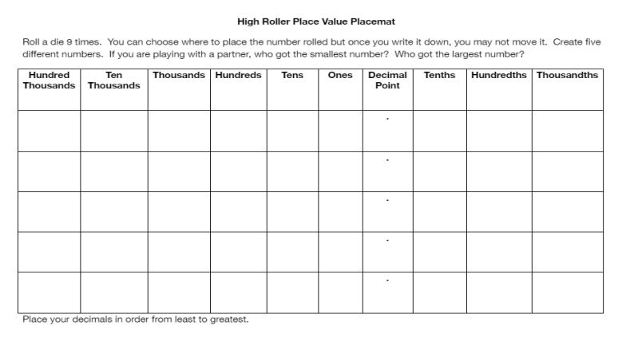
- Decimal Place Value
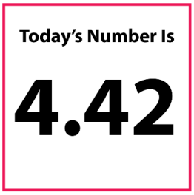
  - How could you represent today’s number with base ten blocks?
  - How could you represent today’s number with money?
  - Can you think of a real-world context that could be written for today’s number to represent?
  - Would today’s number be closer to 4 wholes or 5 wholes? Explain.
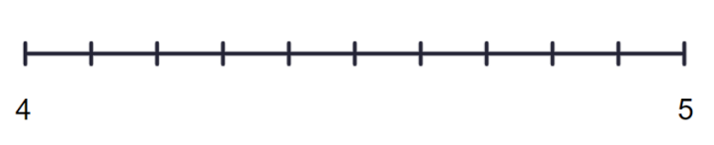
  - Would today’s number be closer to $4.40 or $4.50? Explain.
  - Write a number that would round to 4.42.
  - Write a number that would round to 4.43.

- Subtracting Decimals to Make Them as Close to 1 as Possible
  - Directions: Use the digits 1 to 9, at most one time each, to fill in the boxes to get the difference that is as close to 1 as possible.
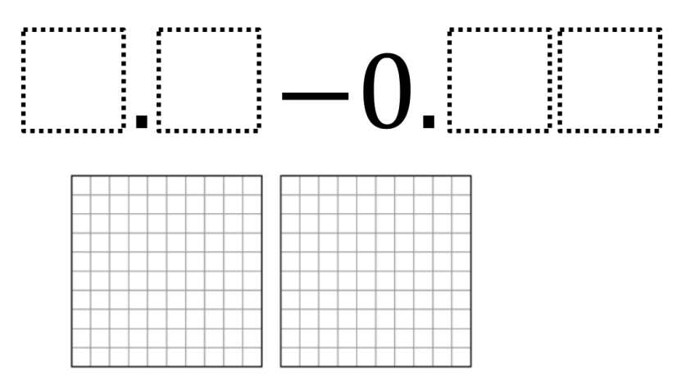
- What’s the Same? What is Different?
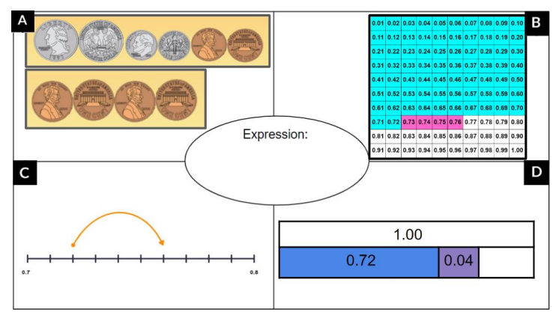
Sample Responses:
- All pictures represent a value of 0.76.
- All pictures can represent the same expression: 0.72 + 0.04
- Two sets of coins are used in picture A.
- A hundredths grid with two different colors is used in picture B.
- A number line is shown in picture C.
- A bar model is used in picture D.
  - Can you take it a step further?
  - Write an expression that can represent each visual.
  - Write a context that could be shown by the visuals.

