Science Unit 2 Study Guide
Part 1: Vocabulary
Complete the following chart on vocabulary about cells and microorganisms
Vocabulary Term | Definition/Function | Illustration/Analogy
Cell
Cell membrane
Cell Wall
Cytoplasm
Nucleus
Chloroplast
Microorganism
Beneficial
Harmful

Part 2: Matching
Match the following organelles to the analogy that best shows its function.
- Cell membrane |  | - A lunchbox that stores water and food and used napkins
- Cell wall |  | - The jello that holds fruits in place
- Cytoplasm |  | - The boss of a business, the person in charge
- Vacuole |  | - The bricks in a house that keep it sturdy
- Nucleus |  | - A chef, making delicious food
- Chloroplast |  | - A bodyguard that decides who goes in an out of a building

Part 3: Multiple Choice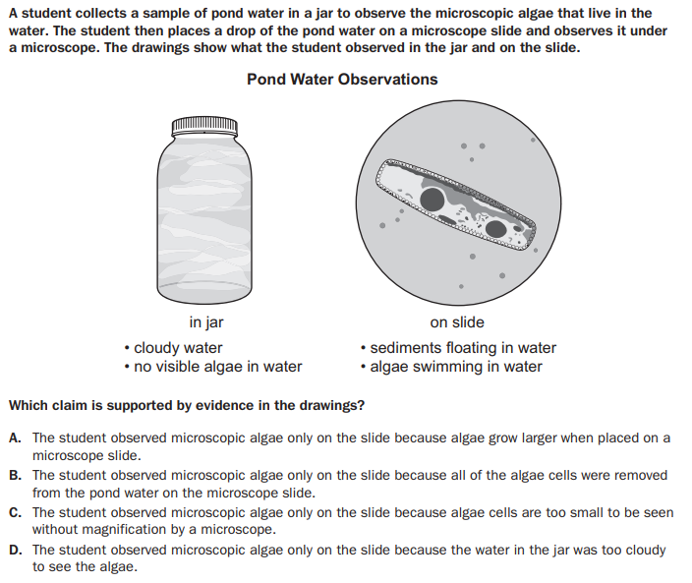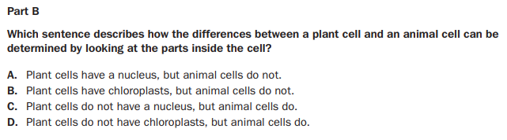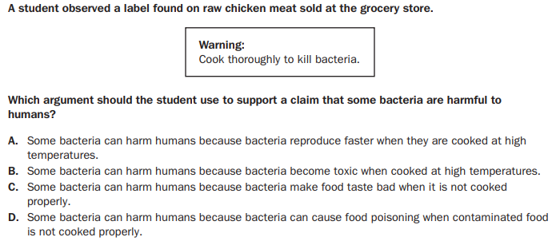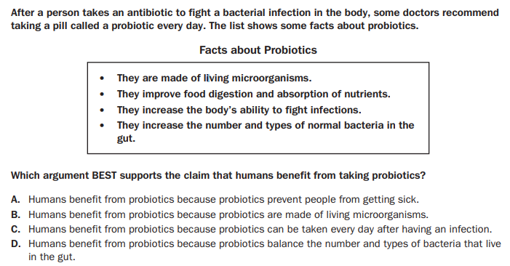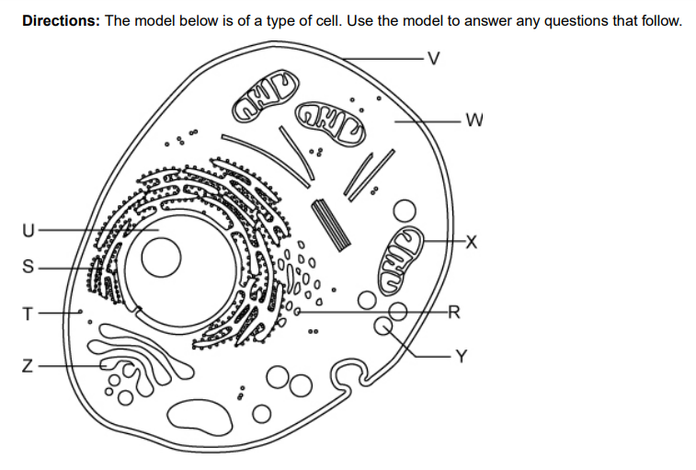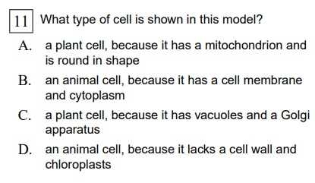

Part A: Sort the following information from the chart below into two categories: Microorganisms that are beneficial, and Microorganisms that are harmful. Be sure to use all the microorganisms in the chart.
Beneficial Microorganisms | Harmful Microorganisms

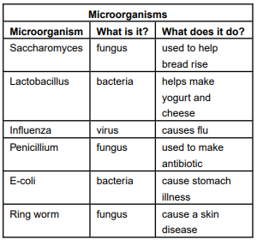
Part B: Choose two microorganisms from the previous chart. Explain in complete sentences how these microorganisms are either helpful or harmful, using details from the chart as evidence. Be sure to write your response by restating, answering, and proving.
_____________________________________________________________________________________________________________________________________________________________________________________________________________________________________________________________________________________________________________________________________________________________________________________________________________________________________________________________________________________________________________________________________________________________________________________________________________________________________________________________

Part 4: Creating a Model
In the space provided below, draw and label a model of a plant cell and an animal cell. Be sure to draw and label all of the following organelles:
Cell Wall | Cell Membrane | Cytoplasm | Nucleus |  | Chloroplast
Animal Cell |  |  |  | Plant Cell

