5th Grade Graduation…
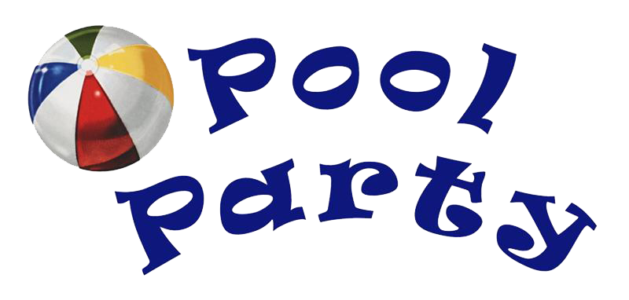

When: Thursday, May 26th
Time: 12:00-2:00 p.m.
Where: Glen Abbey Pool
Cost: $10 (Covers Lifeguards, DJ & Lunch)
PARENTS:
- The waiver is REQUIRED for this pool party (see below)
- You MUST park and walk your child down to the pool gate and sign your child in\out or send in a signed permission for another parent to do so on your behalf. Your child will not be permitted to leave the party without you signing them out at the gate.
- Chaperones will include 5th grade parents.

*** Please send in signed waiver with $10 cash or check by Friday, May 20 to your child’s homeroom teacher Attn/Payable to: NPES PTA or you can pay on the PTA website. After logging in, select “my account” and “forms and paperwork.”

5th Grade Pool Party Waiver

I hereby give consent for my child ___________________________________________to participate in the 5th grade pool party on Thursday, May 26th, 2022 at the Glen Abbey swimming pool. I give permission to allow my child to swim. I also hereby acknowledge that the children are swimming at their own risk, and I hereby release, waive, and covenant not to sue NPES PTA, Glen Abbey HOA or chaperones from any and all liability, claims or causes of action whatsoever arising out of any loss, damage or injury that may be sustained by the child during the pool party.

Coronavirus / COVID-19 Warning & Disclaimer

Coronavirus, COVID-19 is an extremely contagious virus that spreads easily through person-to-person contact. Federal and state authorities recommend social distancing as a mean to prevent the spread of the virus. COVID-19 can lead to severe illness, personal injury, permanent disability, and death. Participating in the 5th grade pool party and accessing the Glen Abbey Clubhouse and pool facilities could increase the risk of contracting COVID-19 by placing my child(ren) in close proximity to other individuals and surfaces that may have been in contact with other individuals.

I agree, represent, and warrant that neither I nor any child(ren) I bring to participate in the 5th Grade pool party is (i) experiencing symptoms of COVID-19, including, without limitation, fever, cough, or shortness of breath or (ii) has a suspected or diagnosed case of COVID-19 or any other communicable disease. Additionally, I agree, represent, and warrant that neither I nor any child(ren) that I bring to participate in the 5th Grade Pool Party has, within the preceding 14 days, (1) visited an area subject to a CDC Level 3 Travel Health Notice, (2) been exposed to any person who had visited an area subject to a CDC Level 3 Travel Health Notice in the 14 days preceding the exposure, or (3) been exposed to any person who has a suspected or diagnosed case of COVID-19.

______________________________________
PARENT/GUARDIAN

______________________________________
DATE

